Provider Portal 3.0 Manual
Table of Contents
Revision History ii
Provider Portal 3
Key Features 3
How to Access the Provider Portal 3
How to login: 3
How to Request Access to the Provider Portal 4
User Types Hierarchy 7
Dashboard 8
Members Module 9
Accessing the Member Module 9
Member Search 9
Member Information 11
Authorizations / Referrals Module 14
Accessing the Authorizations/Referrals Module 14
Search Authorization 14
Authorization Information 19
Submit Authorization / Referrals 23
Claims Module 31
Accessing the Claims Module 31
Search Claims 31
Claims Information 33
Providers Module 37
Accessing the Providers Module 37
Provider Search 37
Provider Information 39
Provider Notices Bulletins 40
Administration 41
Accessing the Administration Module 41
Roles 42
Add New Role 43
Users 44
Search Users 45

Revision History
Version/Release | Date | Description of Revisions | Author
V1.0 | 11/02/2021 | Initial User Guide for GlobalHealth | HAX

All Rights Reserved. The copyright and trade secret laws of the United States and other countries protect this material. No part of this material or software covered by the copyrights herein may be reproduced distributed or altered in any fashion without prior written consent of Health Axis. Content is subject to change without notice. For permission to reproduce or distribute this material please contact Health Axis.

Accessing any system mentioned in this guide constitutes acceptance in accordance with the Terms & Conditions of the website.

Trademarks
Health Axis is a trademark of Health Axis.
Microsoft Windows is a registered trademark of Microsoft Corporation.
All other trademarks and trade names are the property of their respective companies.
Member information shown in this document is for informational purposes only and contains no true member or Protected Health Information (PHI).

Provider Portal
The Provider Portal is a quick resource that allows Providers convenient access to member and claim information. The portal is designed to provide access to: Claim status, Member’s Eligibility, and Authorizations.

Key Features
- Plug in for specific users
- Allows Providers to communicate to the 2.5/IPA portals

How to Access the Provider Portal
Enter the URL links for the Test and Production environments, which are specific to each client:

Link: https://ghprovider.prod.healthaxis.net/login

Note: The Provider Portal cannot be accessed through Internet Explorer, users must use Chrome.

How to login:
Steps | User Actions
1 | Enter your Health Axis Provider Portal user name in the Username field.
2 | Enter your password into the Password field.  NOTE: Your password will be encrypted.
3 | Click the Sign In button.
4 | When the Remember my ID on this computer flag is checked, the username auto populates when next signing in.
5 | When the Forgot Password button is selected, users will be taken to the Account Recovery screen.

How to Request Access to the Provider Portal
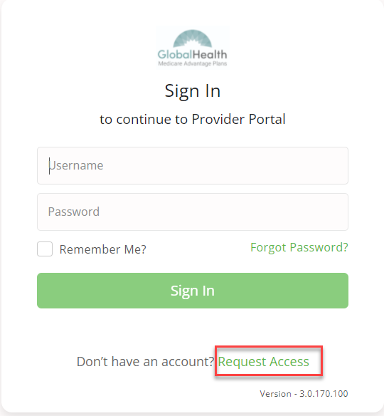
Click the “Request Access” button and the screen below will be displayed. Select “Continue” to proceed. Selecting “Back to Login” will return to the log-in page.
NOTE: New Provider Portal users should request access by contacting the Provider Administrator.
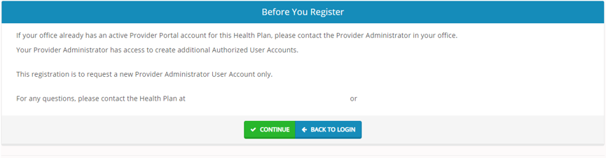

Selecting “Continue” will display the Provider Portal Access Request Form. New provider admin users should request access to the Provider Portal using this form. Fill all the details in the form and submit request to plan administrator. Each of the provider admins will have ability to create “User” accounts. NOTE: There are four possible user types: Physician Admin, Facility Admin, Vendor Admin, and IPA Admin.
Provider Portal Access Request Screen
Field Names | Select Provider Type Section – Field Descriptions
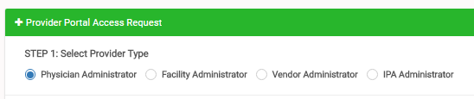
Physician Administrator | The Physician Administrator radio button should be selected for Physician Administrator level access. This user type will have access to information limited to their members only.
Facility Administrator | The Facility Administrator radio button should be selected for Facility/Hospital Administrator level access.
Vendor Administrator | The Vendor Administrator radio button should be selected for Vendor Group/Physician Group Practice Administrator level access. This user type will have access to all member information associated with all the physicians under the group practice.
IPA Administrator | The IPA Administrator radio button should be selected for IPA Administrator level access.
Field Names | Enter Tax ID or NPI Section – Field Descriptions
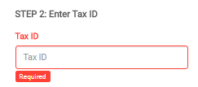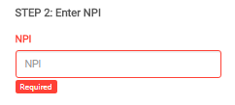

Tax ID | In the Tax ID field, enter the appropriate Tax Identification Number; this field is displayed for Vendor Administrators or IPA Administrators only.  Note: System will validate the TIN is in HAX system. If not found, it will display notification: “Tax ID doesn’t exist in the system.
NPI | In the NPI field, enter the appropriate NPI (National Provider Identifier) number; this field is displayed for Physician Administrators and Facility Administrators only.  Note: System will validate the NPI is in HAX system. If not found, it will display notification: “NPI doesn’t exist in the system.”
Field Names | Create a User Name & Password Section – Field Descriptions
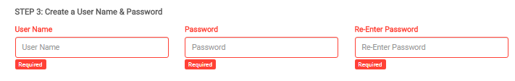
User Name | In the User Name field, create a user name, containing five or more alphanumeric characters.  Note: System will trigger notification “Enter different User Name” if the user name entered is already in use.
Password | In the Password field, create a password containing a minimum of six characters to include: 1 Uppercase, 1 Lowercase, 1 Numeric, and 1 Special Character.
Re-Enter Password | In the Re-Enter Password field, type in the password exactly as it was entered in the password field. Note: System will trigger notification “Value should match password” if there is a discrepancy between the two password fields.
Field Names | Enter Demographic Information Section – Field Descriptions
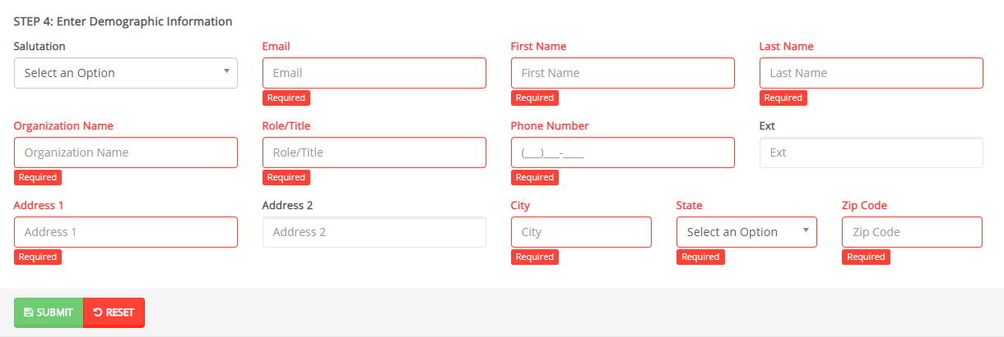
Salutation | Select an optional Salutation for the user from the drop-down list values.
Email | Enter an Email Address for the user. Note: Required field.
First Name | Enter First Name of the user. Note: Required field.
Last Name | Enter Last Name of the user. Note: Required field.
Organization Name | Enter the Organization Name into this field. Note: Required field.
Role/Title | Enter the user’s Role or Title into this field. Note: Required field.
Phone Number | Enter a Phone Number for the user. Note: Required field.
Ext | Enter an extension for the user’s phone number, if applicable.
Address 1 | Enter the user’s Address. Note: Required field.
Address 2 | Continue entering Address from Address 1 field, if applicable.
City | Enter the City into the field. Note: Required field.
State | Select the State from the drop-down list. Note: Required field.
Zip Code | Enter a valid Zip Code. Note: Required field.
Submit | Select Submit when all required fields are completed.
Reset | Select Reset to clear the fields and re-start the form.

Once the Provider Administrator submits a request a popup window as shown below will be displayed stating that your request has been submitted. The user will receive an email notification, once the Administrator approves their User Access.
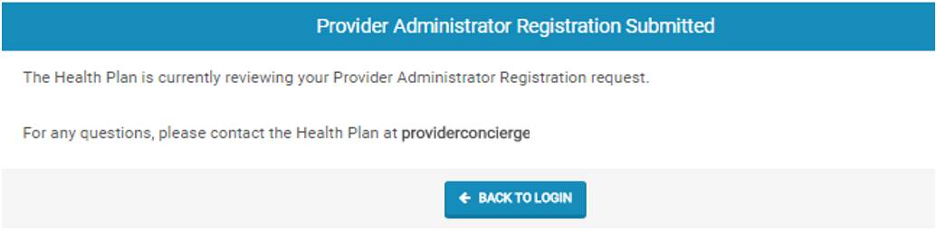

User Types Hierarchy
- System Administrator – Only System Administrators can Approve/Deny a Provider Administrator’s Access Request Form or they can go to Create User Screen, to create a Provider Administrator.
- Provider Administrator (Physician Administrator, Facility Administrator, Vendor Administrator, or IPA Administrator) – There can only be one (1) Provider Administrator per NPI/Tax ID. Only the Provider Administrator can complete the Request Access Form (login screen).
- Provider Authorized Users (Physician Auth. User, Facility Auth. User, Vendor Auth. User, and IPA Auth. User) – Only the Provider Administrators can create a Provider Authorization User account, for their respective NPI/Tax ID. A Provider Authorized User would need to reach out to their designated Provider Administrator to request a user account.

Dashboard
The Dashboard is the landing page displayed once the user logs into the portal. The dashboard gives the user an overview of authorizations by status, Hospital Census Data and Notice Bulletins.

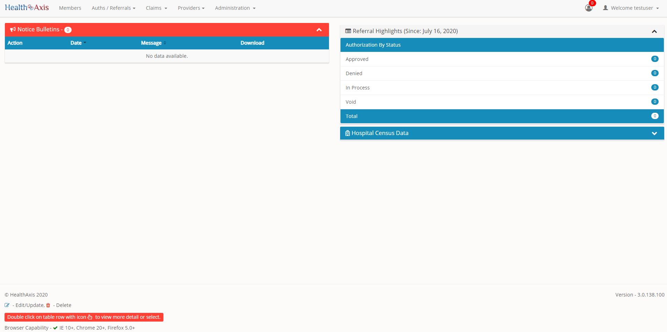

Members Module
The Member Module allows users with specific access to search and view member details.

Accessing the Member Module
Once logged into the system, select Members from the dashboard.

Member Search
Upon selecting “Members,” the Member Search popup window will display. Users may search for members based on the filters provided in the following table.
However, the member search results are dependent on the user roles:
- User – Admin: Can view all active members
- User – Provider: Can only view members that are tied to the PCP
- User – Facility/Vendor: Can search for all members but will need to enter Member ID and DOB or Medicare ID number.

Member Screen
Field Names |  | Member Search Section – Field Descriptions
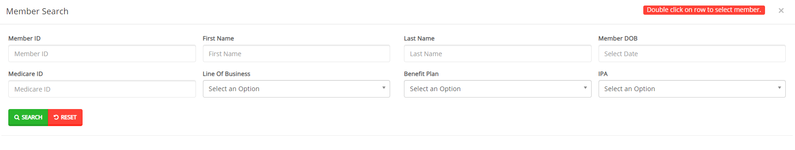
Member ID |  |  | The Member ID allows users to enter the Member’s ID number.
First Name |  |  | The First Name field allows users to enter the member’s First Name.
Last Name |  |  | The Last Name field allows users to enter the member’s Last Name.
Member DOB |  |  | The Member DOB date field allows users to select the Member’s DOB using the calendar feature or by manually keying the member’s DOB in as follows: MM/DD/YYYY
Medicare ID |  |  | The Medicare ID field allows users to enter the Medicare Beneficiary Identifier (MBI) as part of the search criteria.
Line of Business |  |  | The Line of Business field allows users to narrow the member search by selecting a line of business from the dropdown list.
Benefit Plan |  |  | The Benefit Plan field allows users to narrow the member search by selecting a benefit plan from the dropdown list.
IPA |  |  | The IPA field allows users to narrow the member search by selecting an IPA from the dropdown list.
Search |  |  | The Search button allows users to launch the search functionality, based on criteria selected. The results will populate below the search section.
Reset |  |  | The Reset button allows users to clear all data from the fields prior to saving.
Member Search Screen
Field Names |  | Member Results Section – Field Descriptions
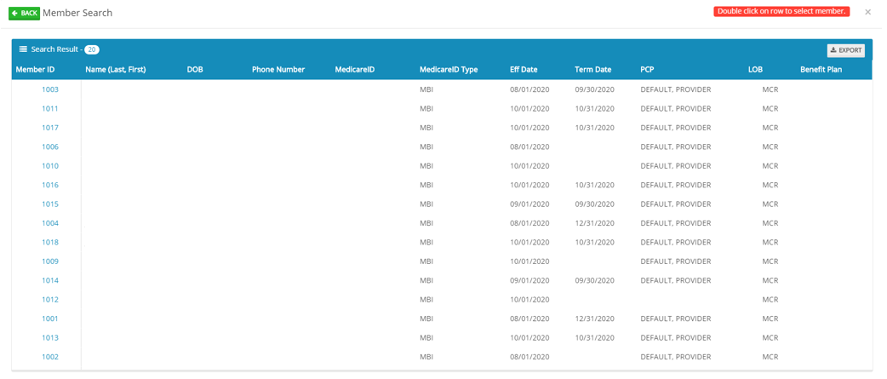
Back | The Back button, when selected, will display the member search field to allow users to enter search criteria.
Search Results | The “Search Results” heading tells the users how many records are displayed in the results table.
Export | The Export button allows the user to export the results data into an Excel format.
Results Table | The Results Table is a sortable display of data based on the search criteria specified and queried. To sort in ascending or descending order, click the header.
Member ID | The Member ID hyperlink allows the user to open and view the Member Details.

Member Information
Upon clicking on the selected member from the grid, the member information will populate into the member information screen. The user can now view the Member’s Information, Current Coverage, Coverage History, IPA/PCP Information, and Coordination of Benefits.
Member Information Screen
Member Information Section
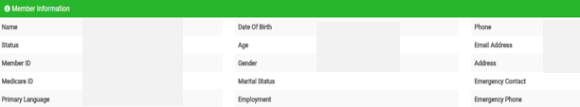
The Member Information section allows users with specific access to view all active members’ demographic information. This information is auto-populated from the HAX 2.5 Claims system and cannot be edited.
Member Information Screen
Current Coverage Section
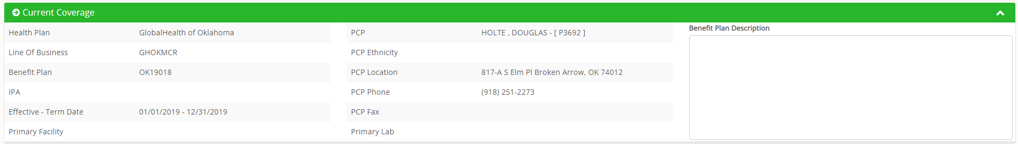
The Current Coverage section allows users with specific access to view all active members’ coverage. This information is auto-populated from the HAX 2.5 Claims system and cannot be edited.

Member Information Screen
Coverage History Section
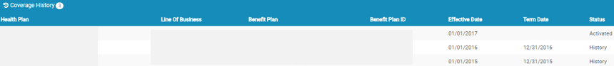
The Coverage History section allows users with specific access to view all active members’ coverage history. This information is auto-populated from the HAX 2.5 Claims system and cannot be edited.

Member Information Screen
IPA/PCP History Section
The IPAPCP History section allows users with specific access to view all active members’ IPA/PCP history. This information is auto-populated from the HAX 2.5 Claims system and cannot be edited.

Member Information Screen
Coordination of Benefits Section
The Coordination of Benefits section allows users with specific access to view all active members’ COBs. This information is auto-populated from the HAX 2.5 Claims system and cannot be edited.

Action Buttons
The Action Buttons at the top of the Member Information screen allows users to perform various tasks within the member information screen.
Member Information Screen
Field Names |  | Action Buttons – Field Descriptions
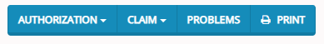
Authorization | The Authorization button allows users to view all authorizations tied to the selected member or create an authorization for the selected member.  Choices are:  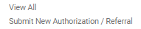
Claim | The Claim button allows users to view all claims tied to the selected member.
Problems | The Problems button allows users to view or manual create a new problem for selected member. Problems will display all ICD codes submitted on a claim or authorization for the member. Problems can be viewed by Date of Service, by ICD code and by the Provider. Use the error located on each collapsible section to expand. Upon clicking the Problems button, the following screen will appear.  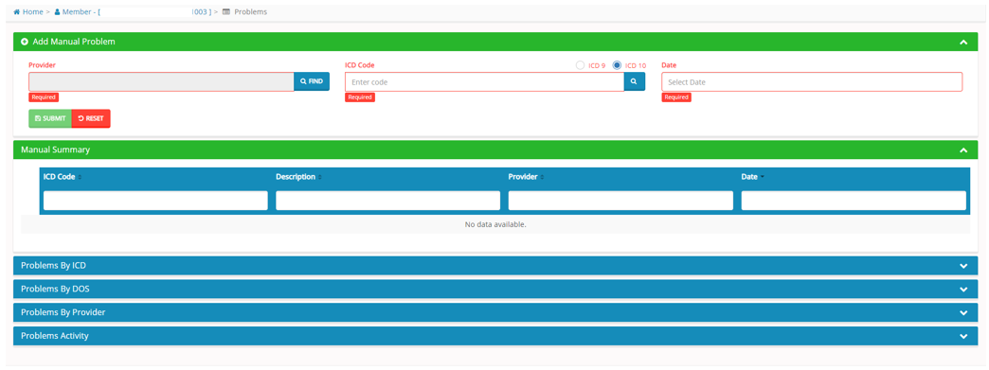
Print | The Print button allows users to print the member information screen.

Authorizations / Referrals Module
The Authorization / Referrals Module allows users with specific access to search, view and submit an authorization or referral request.

Accessing the Authorizations/Referrals Module
Once logged into the system, select Authorizations / Referrals from the dashboard.

The dropdown list for the Authorizations/Referrals Module contains the following selections:

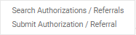

Search Authorization
The Search Authorizations screen will allow users to search for authorizations and referrals based on the filters provided in the following tables.
However, the authorization search results are dependent on the user roles:
- User – Admin: Can view all authorizations and/or referrals for active members.
- User – Provider: Can only view all authorizations and/or referrals of members that are tied to the PCP/Physician.
- User – Facility: Can search for all auth of members where authorizations and/or referrals have their facility.
- User – Vendor: Can search for all authorizations and/or referrals of members where vendor is tied to the providers in the authorization or referral.

Hospital Census Data
Upon clicking the Authorization Module, the Hospital Census Data will display. (If it is collapsed, click the arrow on the right to expand).
Authorization Screen
Hospital Census Data Section
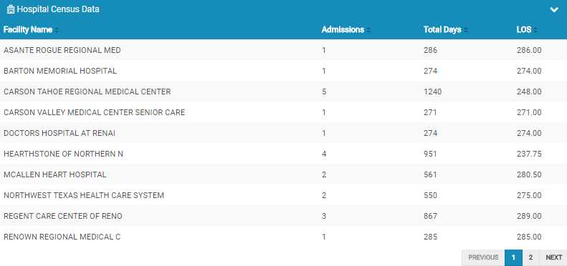
The Hospital Census Data section allows the users to view the number of admissions, total days, and average length of stay for admitted members.

Search Authorization
Upon clicking the Authorization Module, the Search Authorization screen will display. (If it is collapsed, click the arrow on the right to expand).
Authorization Screen
Field Names | Search Authorization Section – Field Descriptions
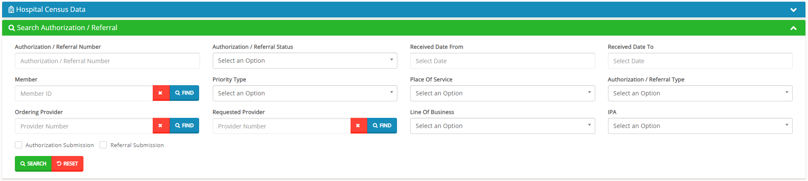
Authorization / Referral Number | The Authorization / Referral Number field allows users to enter an authorization number as part of the search criteria.
Authorization / Referral Status | The Authorization / Referral Status field allows users to select the appropriate Authorization Status from the dropdown list as part of the search criteria.
Received Date From | The Received Date From field allows users to select the “received date from” as part of the search criteria, by either using the calendar, or manually entering the date in the following format: MM/DD/YYYY
Received Date To | The Received Date To field allows users to select the “received date” (to) as part of the search criteria, by either using the calendar, or manually entering the date in the following format: MM/DD/YYYY
Member | The Member field allows the user to enter the member’s name (Last Name, First Name) or click the Find button (shown to the left) to select the member from the Member Search popup window as part of the search criteria.  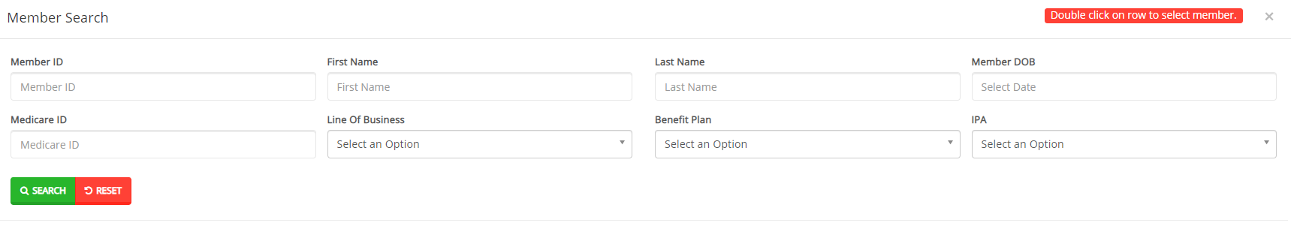
Type | The Type field allows users to narrow an authorization search by selecting the authorization type from the dropdown list.
Place of Service | The Place of Service field allows users to narrow an authorization search by selecting the service location from the dropdown list.
Authorization / Referral Type | The Authorization / Referral Type field allows users to select the appropriate Authorization / Referral Type from the dropdown list.
Ordering Provider | The Ordering Provider field allows users to enter the name of the ordering provider (Last Name, First Name) or click the Find button (shown to the left) to select the provider from the Provider Search popup window as part of the search criteria.  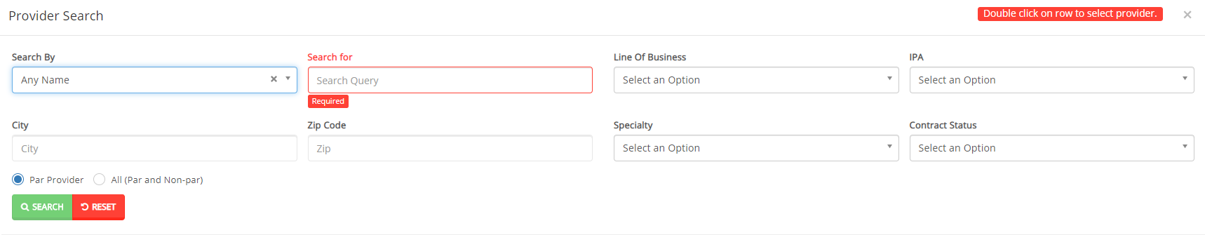
Requested Provider | The Requested Provider field allows users to enter the name of the requested provider (Last Name, First Name) or click the Find button (shown to the left) to select the provider from the Provider Search popup window as part of the search criteria.  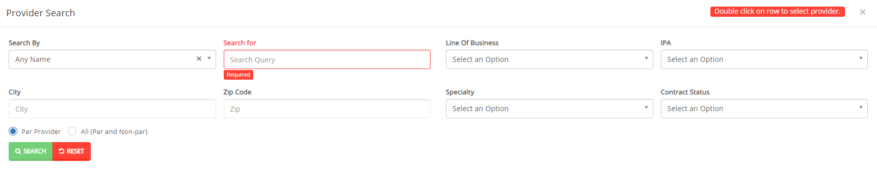
Line of Business | The Line of Business field allows users to select a LOB from the dropdown list as part of the search criteria.
IPA | The IPA field allows users to select an IPA (or Network) from the dropdown list as part of the search criteria.
Authorization Submission | The Authorization Submission flag allows users to select Authorization Submissions only as part of the search criteria.
Referral Submission | The Referral Submission flag allows users to select Referral Submissions only as part of the search criteria.
Search | The Search button allows users to launch the Search Authorization functionality based on the criteria selected. The results will populate below the search section.
Reset | The Reset button allows users to clear all data from the fields prior to saving.

Authorization Screen
Field Names |  | Authorization Results Section – Field Descriptions
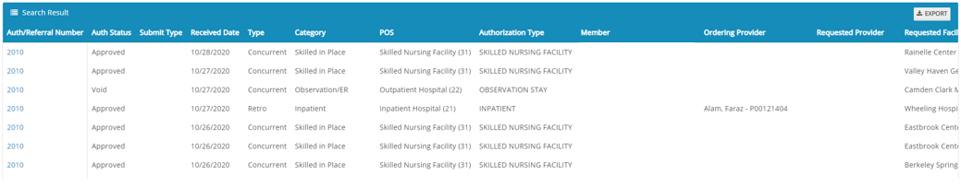
Export | The Export button allows the user to export the results data into an excel format.
Results Table | The Results Table is a sortable display of data based on the search criteria specified and queried. To sort in ascending or descending order, click the header.
Auth / Referral Number | The Auth/Referral Number hyperlink allows the user to open and view the Auth Details.

Authorization Information
Authorization Review Screen
Upon clicking on the selected authorization from the results grid, the authorization review screen will display. The user can view the details of the member’s authorization selected. The authorization review screen consists of the following collapsible sections: member’s information, member’s current coverage, authorization summary, ordering provider, requested facility, requested services, decision and routing information, attachments, notifications (letters), and inpatient tracking log.

Note: Each section can be collapsed for easier viewing. This section is for review only, users will not be allowed to edit.

Authorization Review Screen
Member Information Section
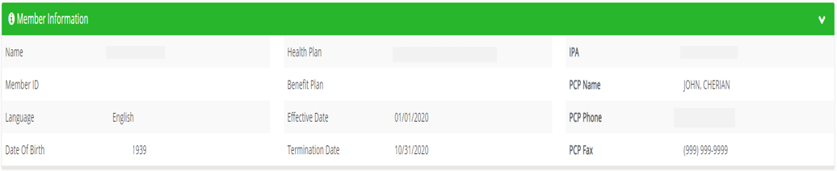
The Member Information section allows users to view the member’s demographic information.
Authorizations Review Screen
Authorization Summary Section
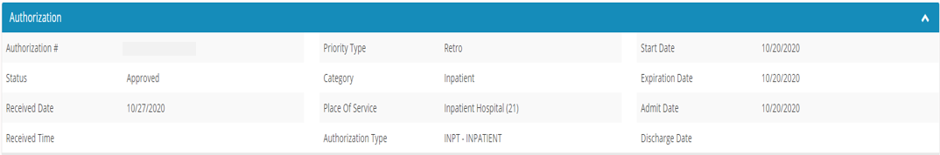
The Authorization Summary section allows users to view the summary details of the member’s authorization.

Authorization Review Screen
Ordering Provider Section
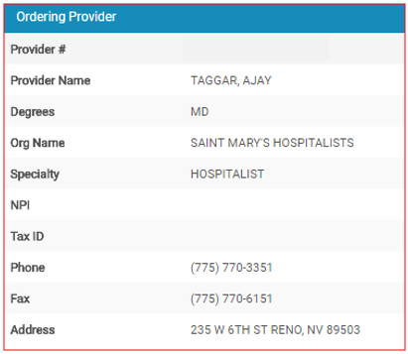
The Ordering Provider section allows users to view the ordering provider’s details.
Authorization Review Screen
Requested Provider Section
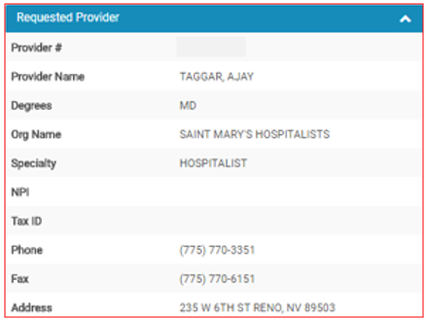
The Requested Provider section allows users to view the requested provider’s details.

Authorization Review Screen
Requested Facility Section
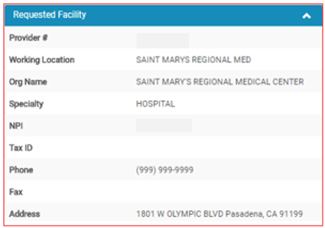
The Requested Facility section allows users to view the requested facility’s details.
Authorization Review Screen
Requested Services Section
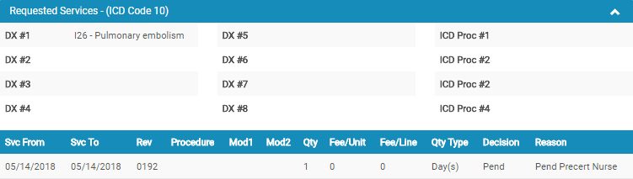
The Requested Services section allows users to view the requested services of the member’s authorization.

Authorization Review Screen
Decision and Routing Information Section
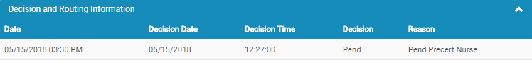
The Decision and Routing Information section allows users to view the decision and routing details of the member’s authorization.

Submit Authorization / Referrals
The Submit New Authorization / Referral screen will allow users to generate an authorization or referral submission in the system by searching for the member and completing the required fields.

Submit Authorization Screen
Field Names | Member Information Section – Field Descriptions
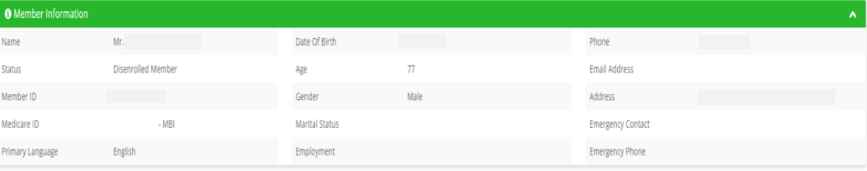
The Member Information section allows users to view the member’s demographic information.
Submit Authorization Screen
Field Names | Current Coverage Section – Field Descriptions
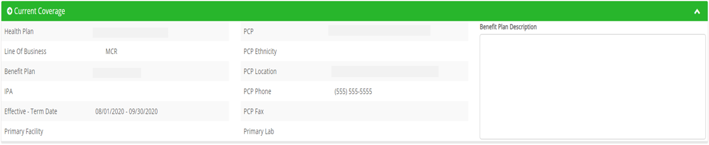
The Current Coverage section allows users with specific access to view all active members’ coverage.

Submit Authorization Screen
Field Names | Authorization Section – Field Descriptions
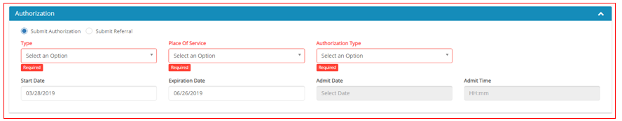
Submit Authorization / Submit Referral | The Submit Authorization / Submit Referral radio buttons allows the user to classify the submission as either an authorization or referral request.
Type | The Type field allows the user to select the priority of the request from the drop-down list. Available options are: Standard and Expedited.
Place of Service | The Place of Service field allows the user to select the place of service from the drop-down list.
Authorization Type | The Authorization Type field allows the user to select the type of authorization from the drop-down list.  Note: The available options depend on the selections in the Type and Place of Service fields.
Start Date | The Start Date field allows the user to select the Authorization / Referral Start date from the calendar or by entering the date in MM/DD/YYYY format.  Note: This field defaults to the current date of submission.
Expiration Date | The Expiration Date field allows the user to select the Authorization / Referral Expiration date from the calendar or by entering the date in MM/DD/YYYY format.  Note: This field defaults to 90 days from the current date of submission.
Admit Date | The Admit Date field allows the user to select the Admission date from the calendar or by entering the date in MM/DD/YYYY format.  Note: This field is only available when specific facilities (i.e. Inpatient Hospital, SNF) are selected in the Place of Service field.
Admit Time | The Admit Time field allows the user to select the Admission time from a drop-down list or enter it in HH:mm format.  Note: This field is only available when specific facilities (i.e. Inpatient Hospital, SNF) are selected in the Place of Service field.

Submit Authorization Screen
Field Names | Ordering Provider Section – Field Descriptions
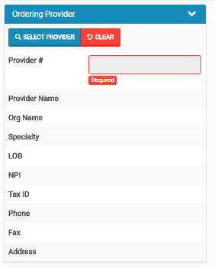
Select Provider | The Select Provider button allows users to perform a provider search and select the appropriate provider record.  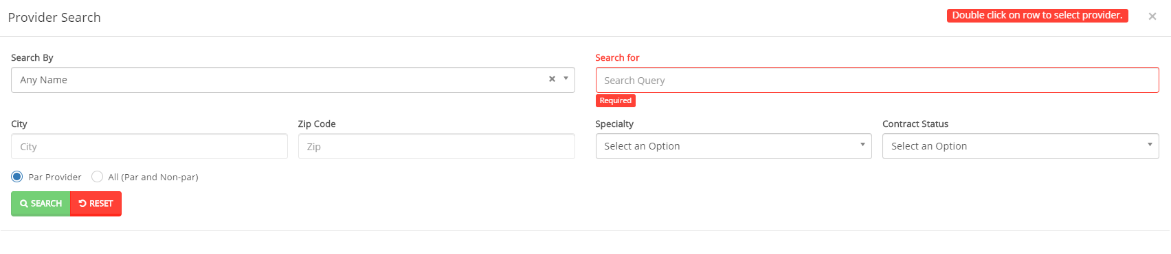
Clear | The Clear button removes the select provider information.
Provider # | The Provider # field auto-populates based on the provider record that is selected.

Submit Authorization Screen
Field Names | Requested Provider Section – Field Descriptions
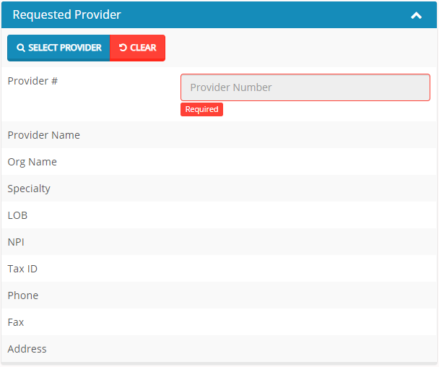
Select Provider | The Select Provider button allows users to perform a provider search and select the appropriate provider record.  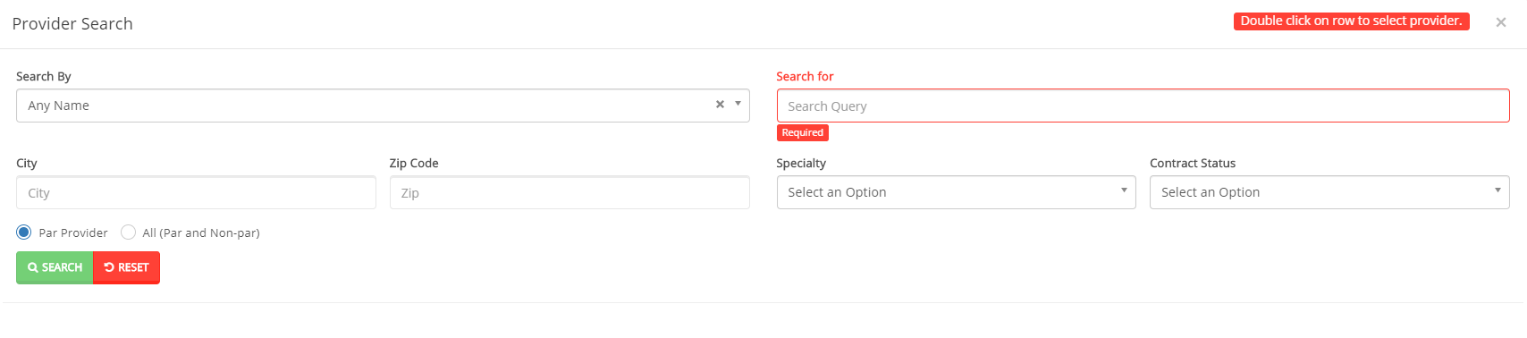
Clear | The Clear button removes the select provider information.
Provider # | The Provider # field auto-populates based on the provider record that is selected.

Submit Authorization Screen
Field Names | Requested Facility Section – Field Descriptions
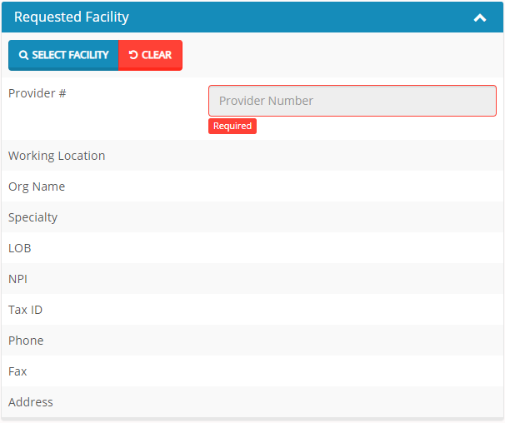
Select Facility | The Select Facility button allows users to perform a facility search and select the appropriate facility record.  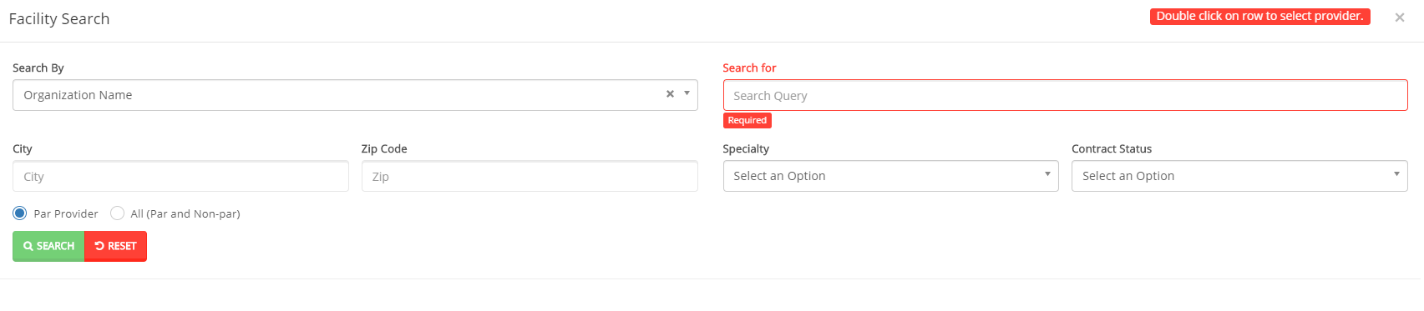
Clear | The Clear button removes the select provider information.
Provider # | The Provider # field auto-populates based on the facility record that is selected.
Working Location | The Working Location field allows the user to select the facility location from the drop-down list.

Submit Authorization Screen
Field Names | Requested Services Section – Field Descriptions
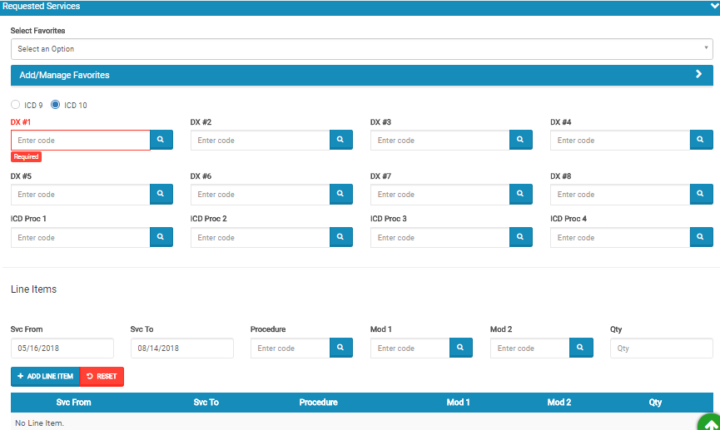
Select Favorites | The Select Favorites drop-down list allows users to select from previously created Favorite templates, that may include DxCodes, ICD Proc Codes, and/or Line Items.
Add / Manage Favorites | The Add/Manage favorites section allows users to add or remove elements from the Favorites drop-down list. To create a favorite, the user must enter a Name, Select the corresponding DxCode, ICD Proc Codes, and/or Line item codes and select Add Favorite.  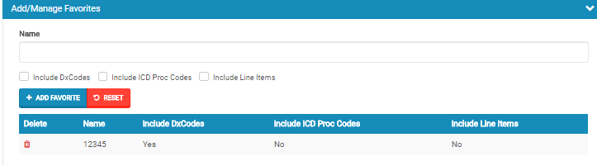
ICD 9 / ICD 10 | The ICD 9 / ICD 10 radio buttons allow the user to specify if the codes that will be entered in the following section are ICD 9 or ICD 10 codes.
DX # 1 - 8 | The DX # fields allow the user to enter up to eight Diagnosis Codes.  Note: Users can enter the code directly into the field or select the magnifying glass to perform a search of all diagnosis codes.
ICD Proc 1 - 4 | The ICD Proc fields allow the user to enter up to four ICD Procedure Codes.  Note: Users can enter the code directly into the field or select the magnifying glass to perform a search of all ICD procedure codes.
Svc From | The Svc From field allows the user to select the Service from Date from a calendar or enter the date in MM/DD/YYYY format.
Svc To | The Svc To field allows the user to select the Service to Date from a calendar or enter the date in MM/DD/YYYY format.
Procedure | The Procedure field allows users to enter the Procedure Code.  Note: Users can enter the code directly into the field or select the magnifying glass to perform a search of all procedure codes.
Mod 1 - 2 | The Mod 1 - 2 fields allow the user to enter up to two Modifiers.  Note: Users can enter the code directly into the field or select the magnifying glass to perform a search of all modifiers.
Qty | The Qty field allow the user to enter the quantity amount.
Add Line Item | The Add Line Item button allows the user to add the selection to the results table.
Reset | The Reset fields removes all information from the Requested Services field prior to saving.
Submit Authorization Screen
Field Names | Attachments/ Clinical Information Section – Field Descriptions
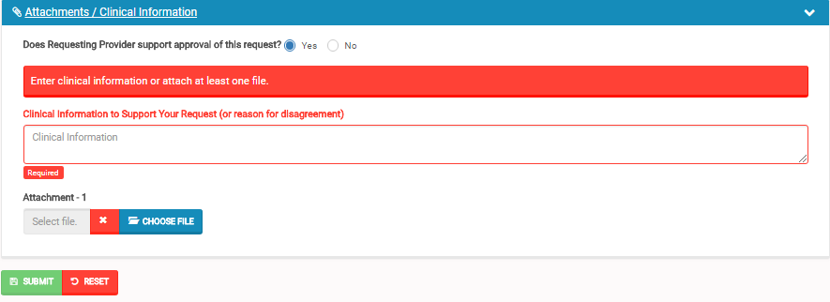
Does Requesting Provider support approval of this request? | The Does Requesting Provider support approval of this request? Radio button allows the user to select if the provider submitting the authorization or referral request is in approval of the services being requested.
Clinical Information to Support Your Request (or reason for disagreement) | The Clinical Information to Support Your Request fields allow the user to enter the clinical information that supports or provides a disagreement reason for the authorization request.  Note: This is a required field for authorization submissions and optional for referrals.
Attachment | The Attachment-1 field allows users to choose a file to be attached by clicking the “choose file” button (shown above). Once a file has been selected it will be displayed in the attachment field.  The red X (shown left) will clear the selected file.
Submit | The Submit button allow the user to submit the Authorization / Referral request.
Reset | The Reset button removes all information entered for the Authorization / Referral request, prior to saving.

Claims Module
The Claims Module allows users to search claims using specific search criteria.

Accessing the Claims Module
Once logged into the system, select Claims from the dashboard.

The dropdown list for the Claims Module contains the following selection:

Search Claims
Upon clicking the Claims Module, the Search Claim Popup Window will appear.
Claim Screen
Field Names | Search Claim Section – Field Descriptions
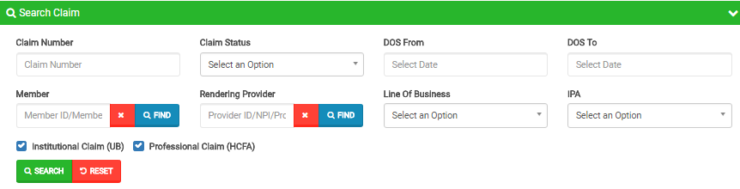
Claim Number |  |  | The Claim Number field allows the user to enter the claim number as part of the search criteria.
Claims Status |  |  | The Claims Status dropdown list allows users to select the claim status from the dropdown list as part of the search criteria.
DOS From |  |  | The DOS From field allows users to select the date of service from using the calendar feature or by manually keying the date in as follows: MM/DD/YYYY
DOS To |  |  | The DOS To field allows users to select the date of service to using the calendar feature or by manually keying the date in as follows: MM/DD/YYYY
Member |  |  | The Member field allows the user to enter the member’s name (Last Name, First Name) or click the Find button (shown to the left) to select the member from the Member Search popup window as part of the search criteria.
Rendering Provider |  |  | The Rendering Provider field allows users to enter the name of the rendering provider (Last Name, First Name) or click the Find button (shown to the left) to select the provider from the Provider Search popup window as part of the search criteria
Line Of Business |  |  | The Line Of Business dropdown list allows users to select the LOB as part of the search criteria.
IPA |  |  | The IPA dropdown list allows users to select the IPA as part of the search criteria.
Institutional Claim |  |  | The Institutional Claim check box allows users to select only institutional claims as part of the search criteria.
Professional Claim |  |  | The Professional Claim check box allows users to select only professional claims as part of the search criteria.
Search |  |  | The Search button allows users to launch the Claim Search functionality based on the criteria selected. The results table will populate below with the respective data fields selected.  Note: Clicking Search with no search criteria will return all results.
Reset |  |  | The Reset button allows users to clear all data from the fields prior to saving.
Claim Screen
Field Names | Claims Results Section – Field Descriptions
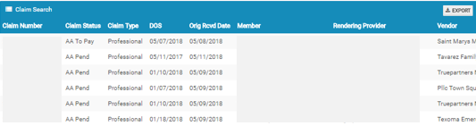
Export |  | The Export button allows the user to export the results data into an excel format.
Results Table |  | The Results Table is a sortable display of data based on the search criteria specified and queried. To sort in ascending or descending order, click the header.
Claim Number |  | The Claim Number hyperlink allows the user to open and view the claim details.

Claims Information
Claims Review Screen
Upon double clicking on the selected claim from the grid, the claim review screen will be displayed. The user will be allowed to view the details of the member’s claim selected.

The claims review screen consists of the following collapsible sections: member’s information, member’s current coverage, claim header, provider or facility information, claim process detail, claim details, coordination of benefits, attachments, authorization information, anesthesia, ambulance, and check details.

Note: Each section can be collapsed for easier viewing. This section is for review only, users will not be allowed to edit.
Claims Review Screen
Claim Header Section
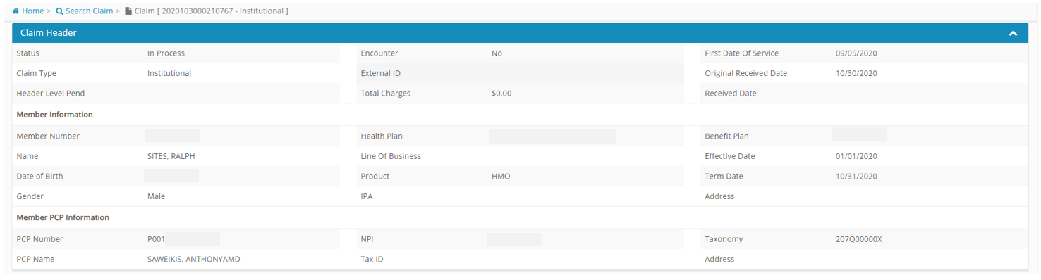
The Claim Header section allows the users to view the Claim Member’s Summary, the Claim Member’s Information, and the Claim Member’s PCP Information.

Claims Review Screen
Provider or Facility Information Section
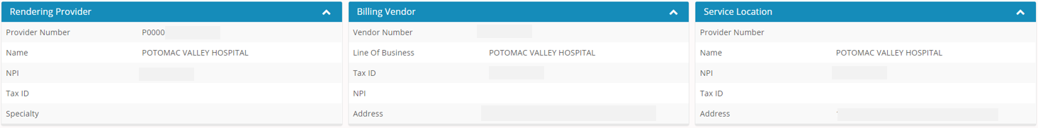
The Provider or Facility Information section allows users to view the rendering and referring provider/facility information of the member’s claim.
Claims Review Screen
Claim Process Detail Section
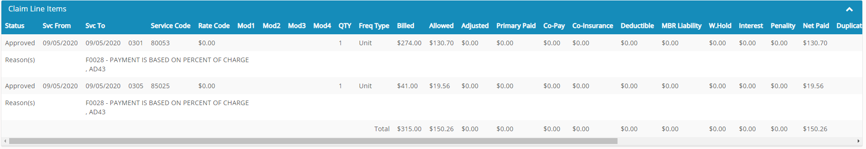The Claim Line Items section allows the users to view the details of a processed claim.

Claims Review Screen
Claim Details Section
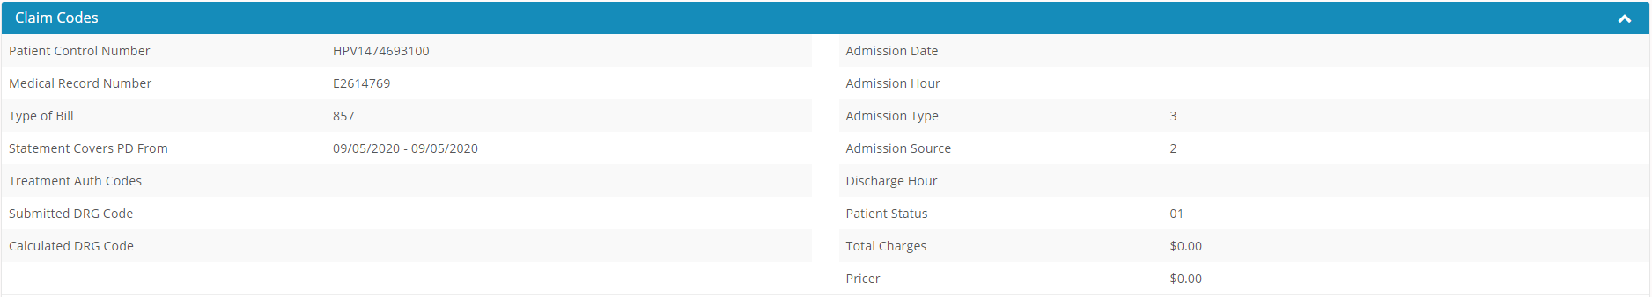
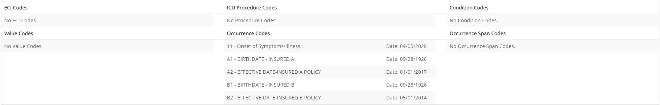
The Claim Codes section contains Claim Codes and DX Codes. The Claim Codes section allows users to view the member’s claim detail information, along with the claim codes and dx codes on the claim.

Claims Review Screen
Coordination of Benefits Section
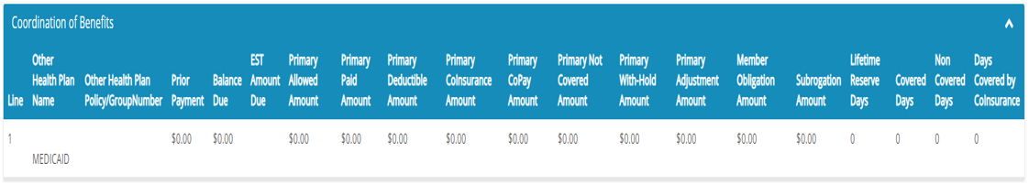
The Coordination of Benefits section allows users to view COB’s on the member’s claim.
Claims Review Screen
Check Details Section
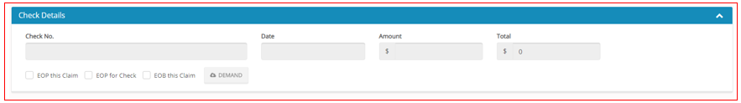
The Check Details section allows users to view the check details on the member’s claim. This section will be present for all finalized claims.

Providers Module
The Provider Module allows users search providers using specific search criteria.

Accessing the Providers Module
Once logged into the system, select Providers from the dashboard.

The dropdown list for the Providers Module contains the following selections:
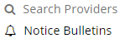

Provider Search
Upon clicking the Provider Module, the Provider Search Popup Window will appear.
Provider Search Screen
Field Names | Provider Search Section – Field Descriptions
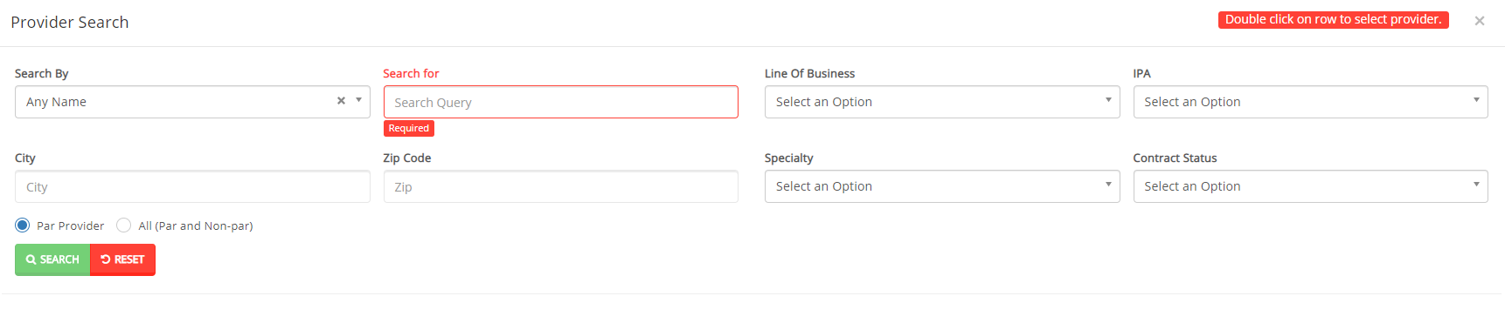
Search By |  | The Search By field contains a dropdown list that can be utilized to narrow down a search to only display providers with specific criteria. Choices are: Any Name, Last Name, First Name, TIN, NPI, Provider Number and Organization Name.
Search For |  | The Search For fields corresponds to the selection chosen in the Search By field.  EX: Smith  NOTE: An entry is required in this field, if a selection is made in the “Search By” field.
Line of Business |  | The Line of Business dropdown list allows users to select a LOB as part of the search criteria.
IPA |  | The IPA dropdown list allows users to select an IPA as part of the search criteria.
City |  | The City field allows users to enter the city as part of the search criteria.
Zip Code |  | The Zip Code field allows users to enter the zip code as part of the search criteria.
Specialty |  | The Specialty dropdown list allows users to select a specialty as part of the search criteria.
Contract Status |  | The Contract Status dropdown list allows users to select the contract status for the provider as part of the search criteria.
Par Provider |  | The Par Provider radio button allows users to select only Par providers as part of the search criteria.
All (Par and Non-par) |  | The All radio button allows users to select both Par and Non-Par providers as part of the search criteria.
Search |  | The Search button allows users to launch the Provider Search functionality based on the criteria selected. The results table will populate below with the respective data fields selected.  Note: Clicking Search with no search criteria will return all results.
Reset |  | The Reset button allows users to clear all data from the fields prior to saving.
Provider Search Screen
Field Names | Provider Results Section – Field Descriptions
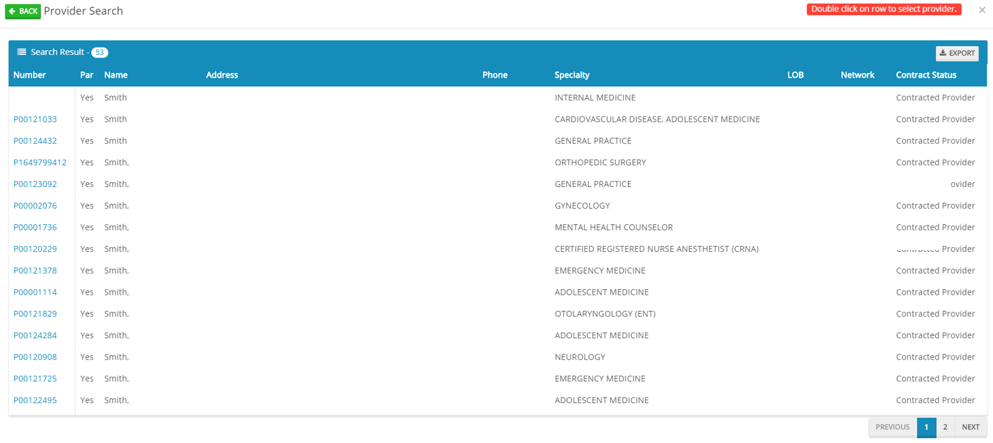
Search Results |  | The Search Results heading tells the users how many records are displayed in the results table.
Export |  | The Export button allows the user to export the results data into an excel format.
Results Table |  | The Results Table is a sortable display of data based on the search criteria specified and queried. To sort in ascending or descending order, click the header.
Previous |  | The Previous button allows user to return to the previous page of the search results.
Next |  | The Next button allows user to skip to the next page of the search results.
Edit Pencil |  | The Edit (Blue) Pencil allows the user to open and view the message details.

Provider Information
Provider Information Screen
Upon double clicking on the selected provider from the grid, the provider information will populate into the provider information screen. The user can now view the Provider Information and the Provider Assignment Details.

Note: Each section can be collapsed for easier viewing. This section is for review only, users will not be allowed to edit.

Provider Information Screen
Provider Information Section
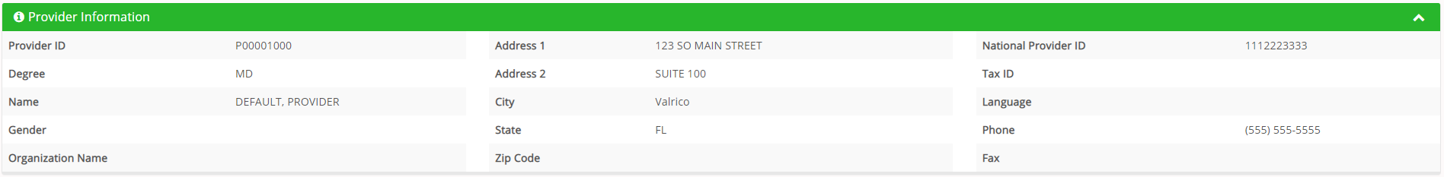
The Provider Information section allows the users to view the demographics of the Provider.
Provider Information Screen
Provider Assignment Section
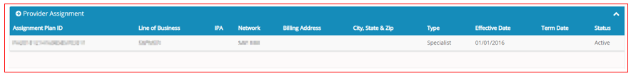
The Provider Assignment section allows users to view the provider assignment plans.

Provider Notices Bulletins
Provider Notices/Announcements allows users to search for notices and announcements.
Search Announcements Screen
Field Names | Announcement Section – Field Descriptions
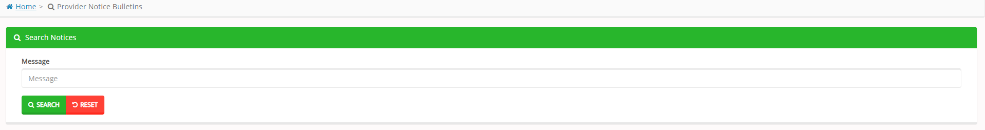
Message |  |  | The Message field allows users to search by the message entered.
Search |  |  | The Search button allows the user to launch the Provider Notices/Announcements search based on the criteria selected/entered. The results table will be populated below with the respective data fields selected.  Note: Clicking Search with no search criteria will return all results.
Reset |  |  | The Reset button allows users to clear all data from the fields prior to saving.
Provider Notices/ Announcements Screen
Field Names | Provider Notices/Announcements Results Section – Field Descriptions
Results Table |  | The Results Table is a sortable display of data based on the search criteria specified and queried. To sort in ascending or descending order, click the header.

Administration
The administration module allows users with administrative privileges to manage user accounts in the Provider Portal. The user will have access to create, terminate or update a user level account details. The user will have access to view the activity log and set up the system’s preferences.

Accessing the Administration Module
Once logged into the system, select Administration dropdown list from the dashboard.

The dropdown list for Administration Module contains the following selections:
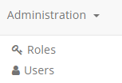

Roles
User can add a new role or choose the existing roles. Roles are tied to permissions which allows the users to navigate through the portal.
Administration Roles Screen
Field Names | Search Roles Section – Field Descriptions
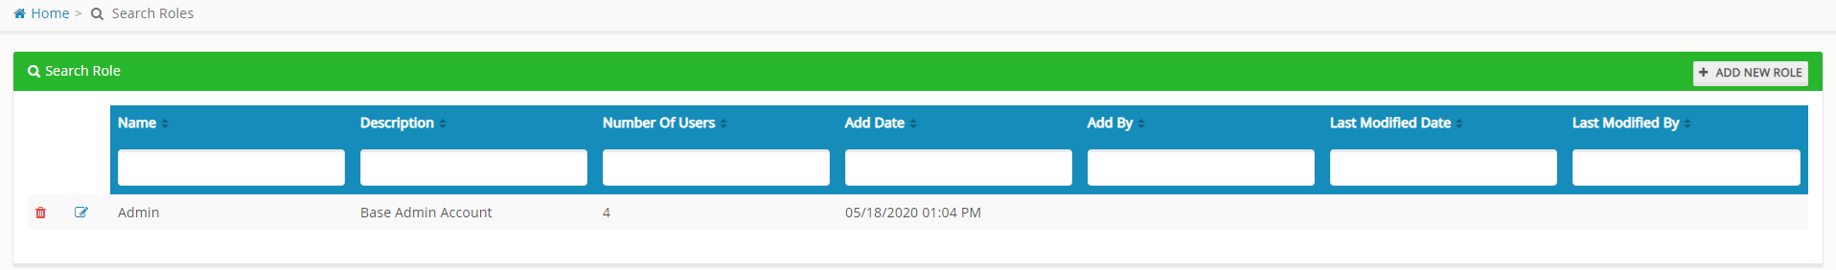
Add New Role |  | The Add New Role button allows specific users to create new roles. The fields will be described in the following table.
Name |  | The Name field allows users to narrow down the search criteria by entering a name.
Description |  | The Description field allows users to narrow down the search criteria by entering a description of the role.
Number of Users |  | The Number of Users field allows displays the number of users assigned to the role.
Add Date |  | The Add Date field allows users to narrow down the search criteria by entering a date.
Add By |  | The Add By field allows users to narrow down the search criteria by entering a date.
Last Modified Date |  | The Last Modified Date field allows users to narrow down the search criteria by entering a date.
Last Modified By |  | The Last Modified By fields allows users to narrow down the search criteria by entering a user name.
Delete Icon |  | The Delete Icon (red trash can) allows specific users to delete the selected user role.
Edit Icon |  | The Edit Icon (blue pencil) allows specific users to edit/update the selected user role.

Add New Role
The Add New Role allows the user to create a new role. The user will need to enter the Role Name, the Role description and select the permissions needed for the role.
Note: As the Physician/Facility/Vendor Administrator, you will need to create the role based on below selection.
Administration Roles Screen
Field Names | Add Roles Section – Field Descriptions
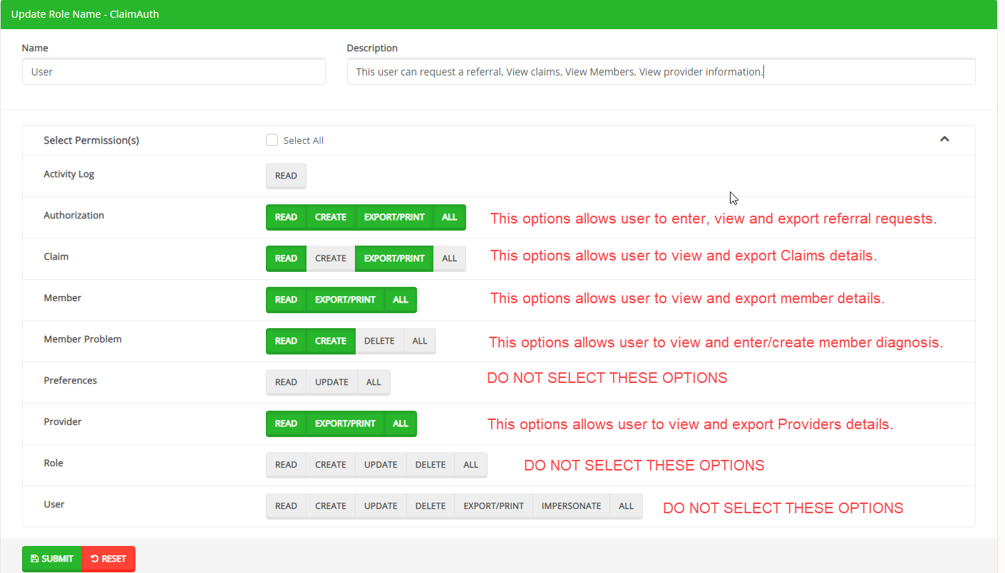
Name |  | The Name field allows users to enter a name for the role. Enter exactly as shown in the above image.
Description |  | The Description field allows users to enter a description for the role. Enter exactly as shown in the above image.
Select Permissions |  | The Select Permission section allows users to select the user’s access within each module and section of the Provider Portal. User Roles are created with specific accesses that include: Read only, Create, Update, Delete, or ALL, among others settings per the corresponding modules.  Important Note: Please select the options exactly as shown in above image.
Submit |  | The Submit button allows users to submit the changes to the role.
Reset |  | The Reset button allows users to clear all data from the fields prior to saving.

Users

Provider, Facility, Vendor Administrators will be able to grant access to the new users by following below steps.
Under Administration Users module you will find below options “ADD NEW USER”
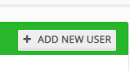
Please fill out below details about the new user.
Note: Please select the role you just created following the steps in the “Roles” section above.
Administrators will be able to see all providers associated to their account. As an administrator, you can allow the new users to have access to some or all providers by moving the Providers from “Provider(s) available” section to “Providers Included” section.

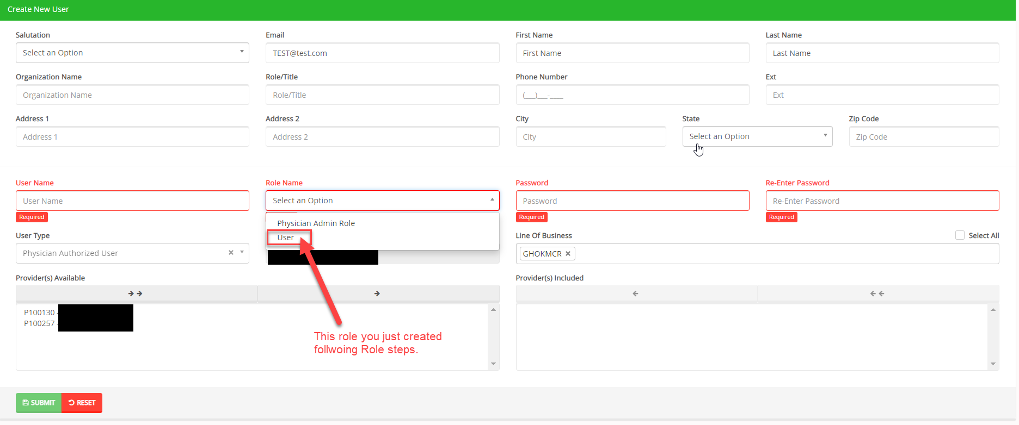

The user requesting access to the provider portal will receive an email confirmation.

Search Users
From the search users screen, click on the edit icon () next to the record you would like to update.

The Edit Pencil option allows Administrators to edit, update and delete user. Administrator can also assign additional providers to the users.
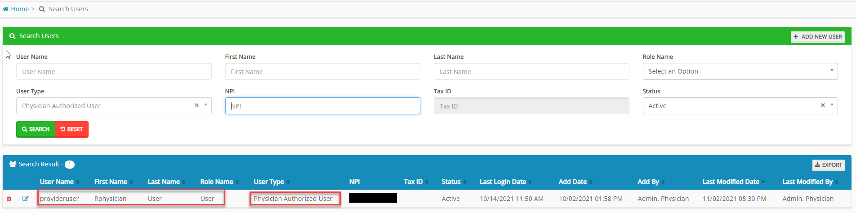

Questions

